UTS QUESTIONS

Name : Evan Diantha Fafian

Class : SIB 2G

Absent : 09

NIM : 2341760163

OBJECT-BASED PROGRAMMING PRACTICUM

1. Identify the following diagram class, make complete improvements and in accordance with the rules for writing the diagram class.

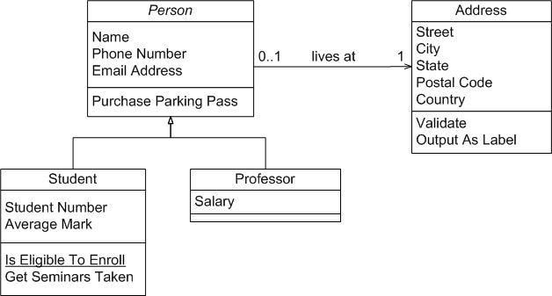

My Answer :

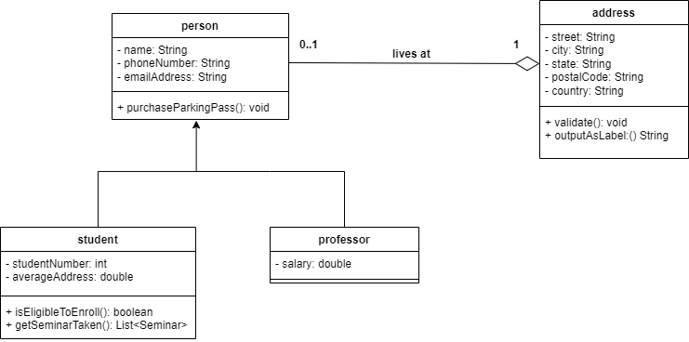

1. Create a diagram class that uses multilevel inheritance and create the program code!

My Answer :

* Person

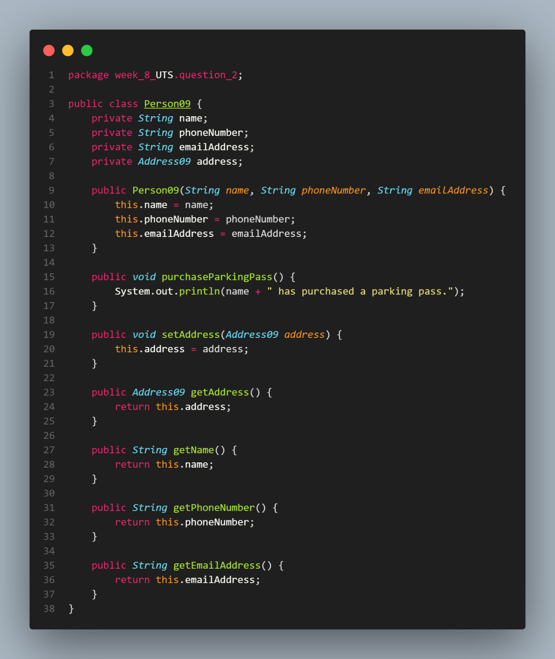

* Student

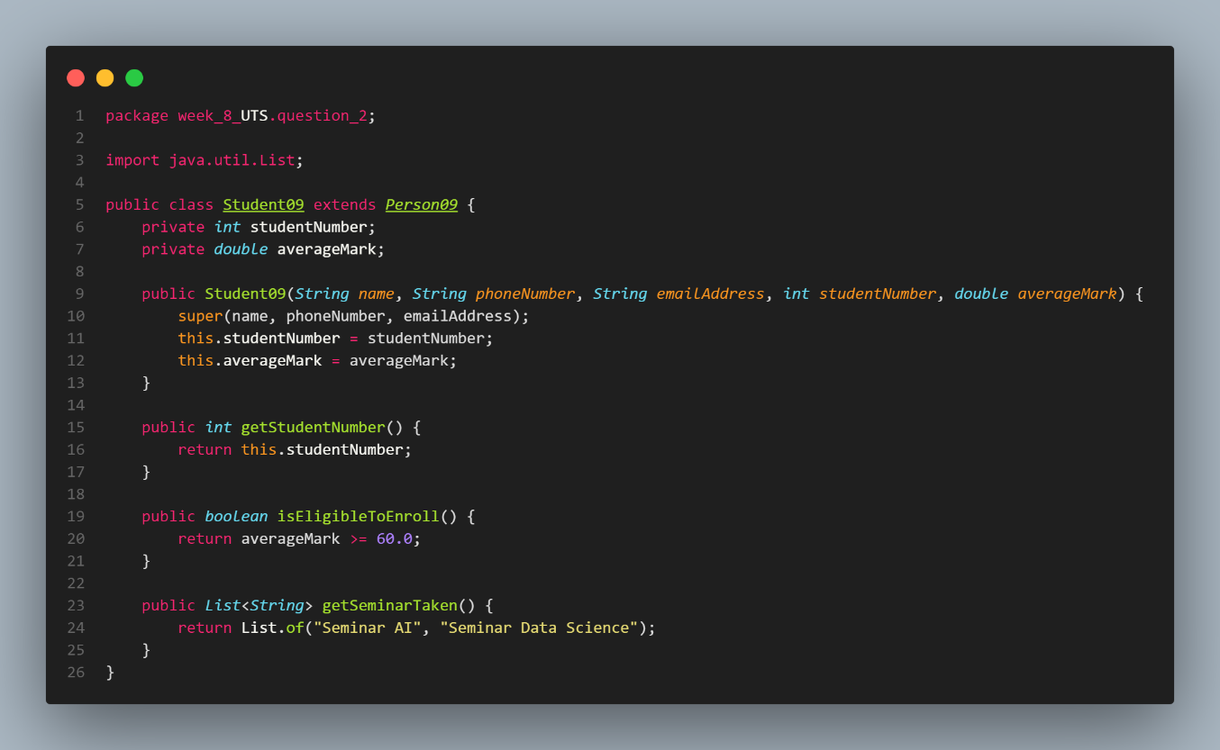

* Professor

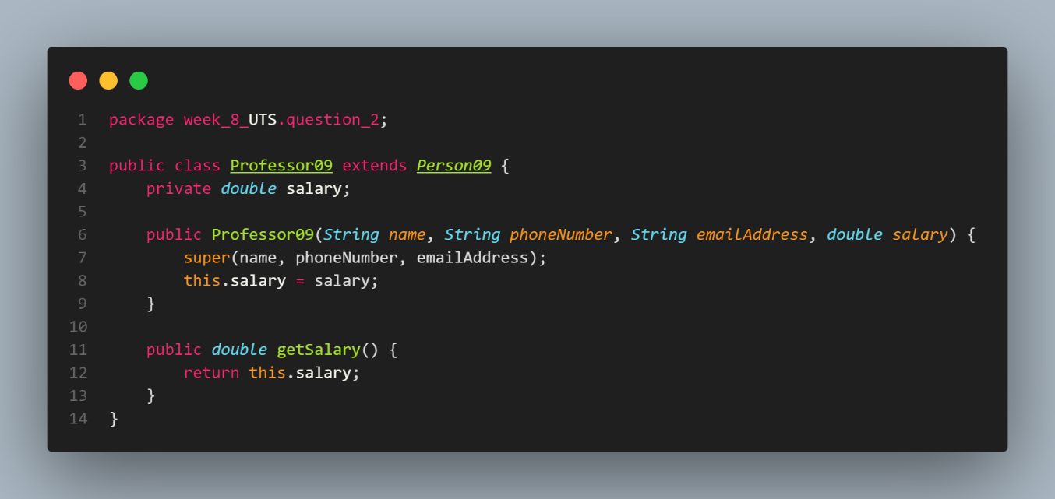

* Address

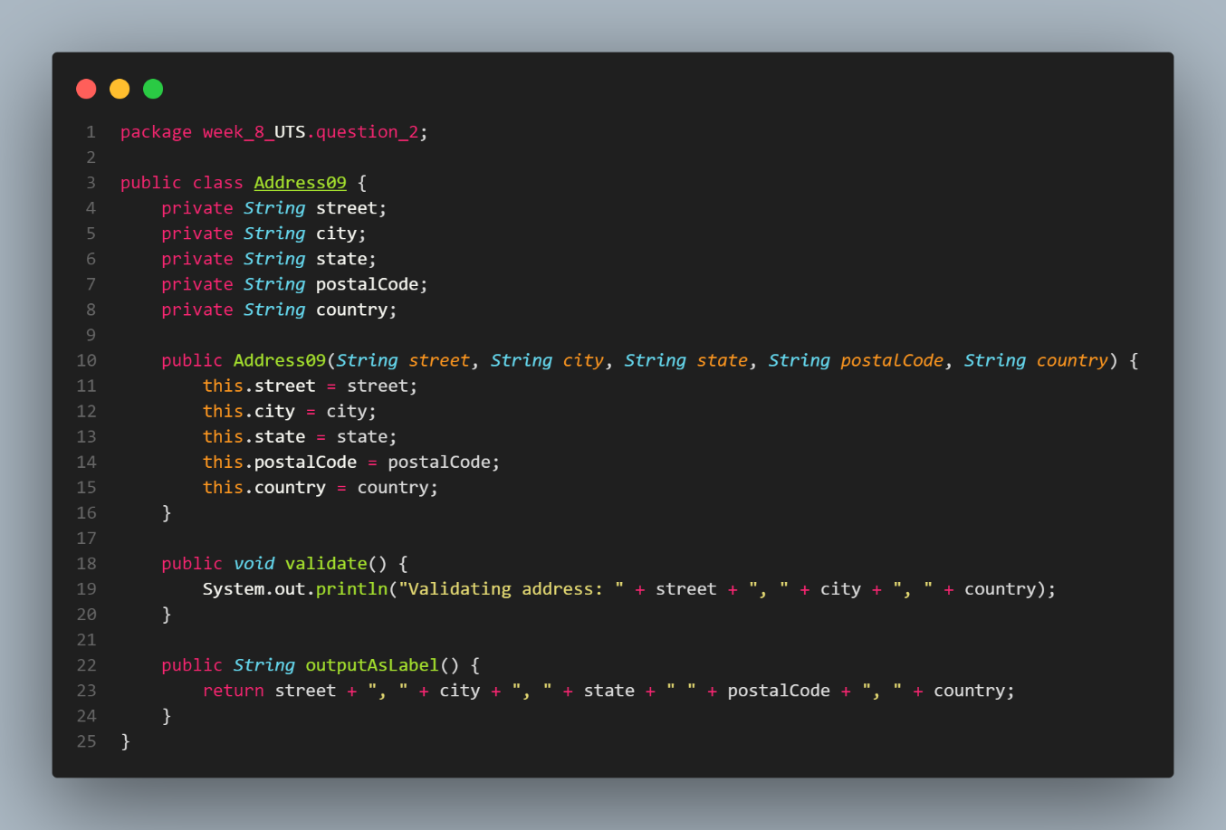

* Main

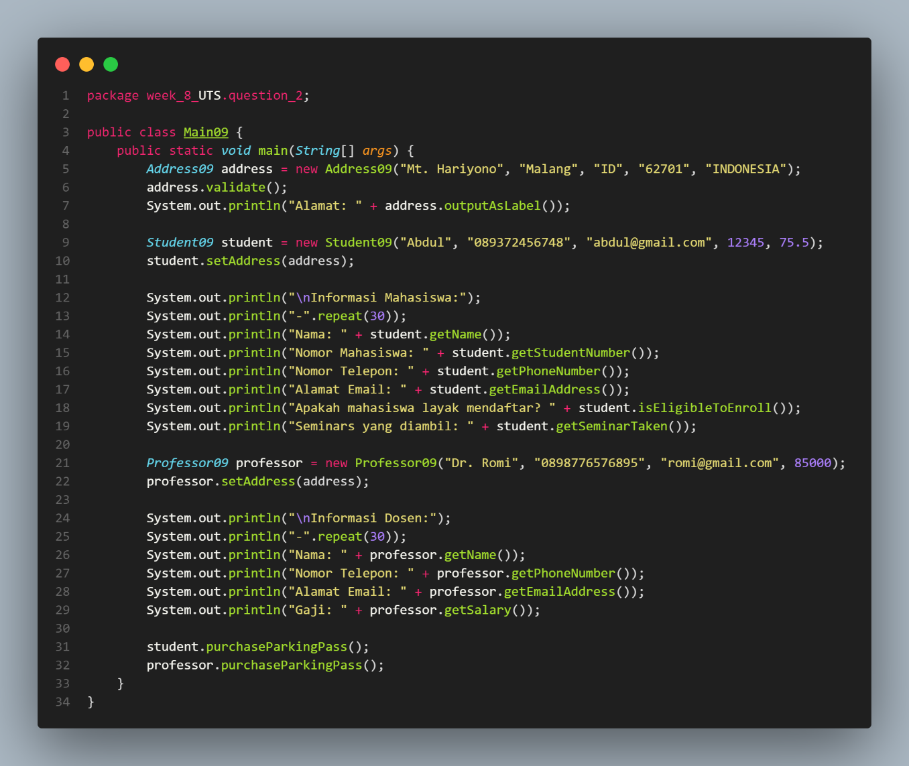

1. Please identify the class diagram by providing an explanation of the concept of inheritance, the relationship between classes and the following system flow, create a program code from the following class diagram!

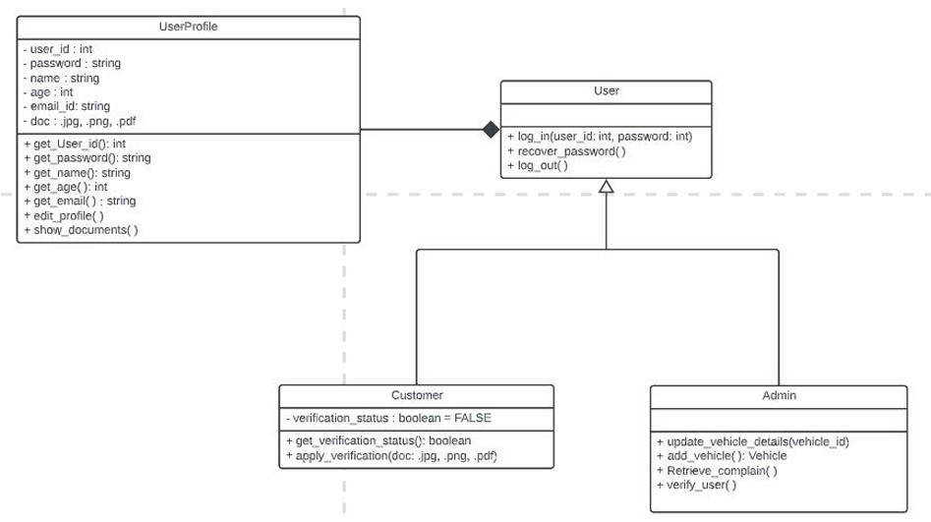

My Answer :

* UserProfile

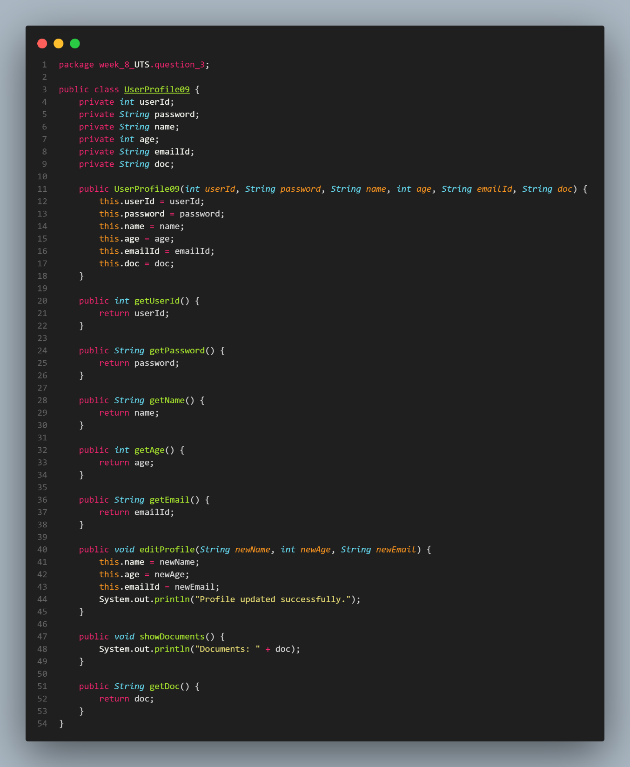

* User

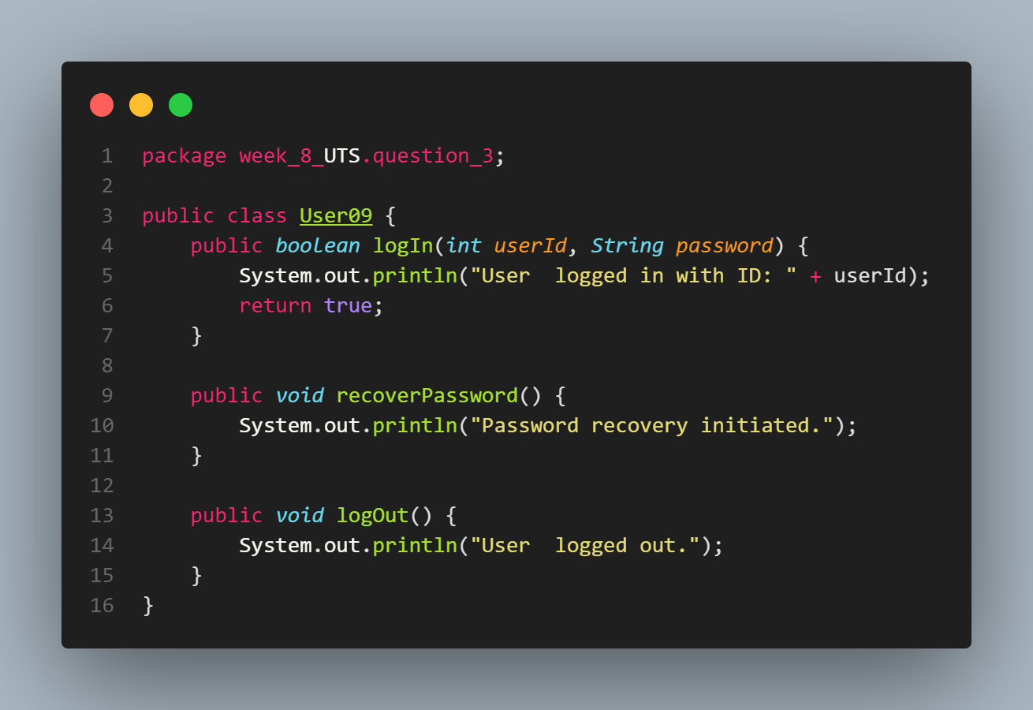

* Customer

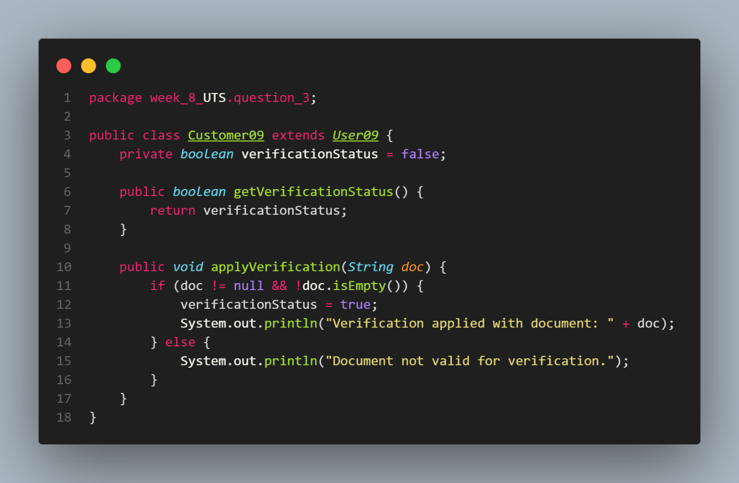

* Admin

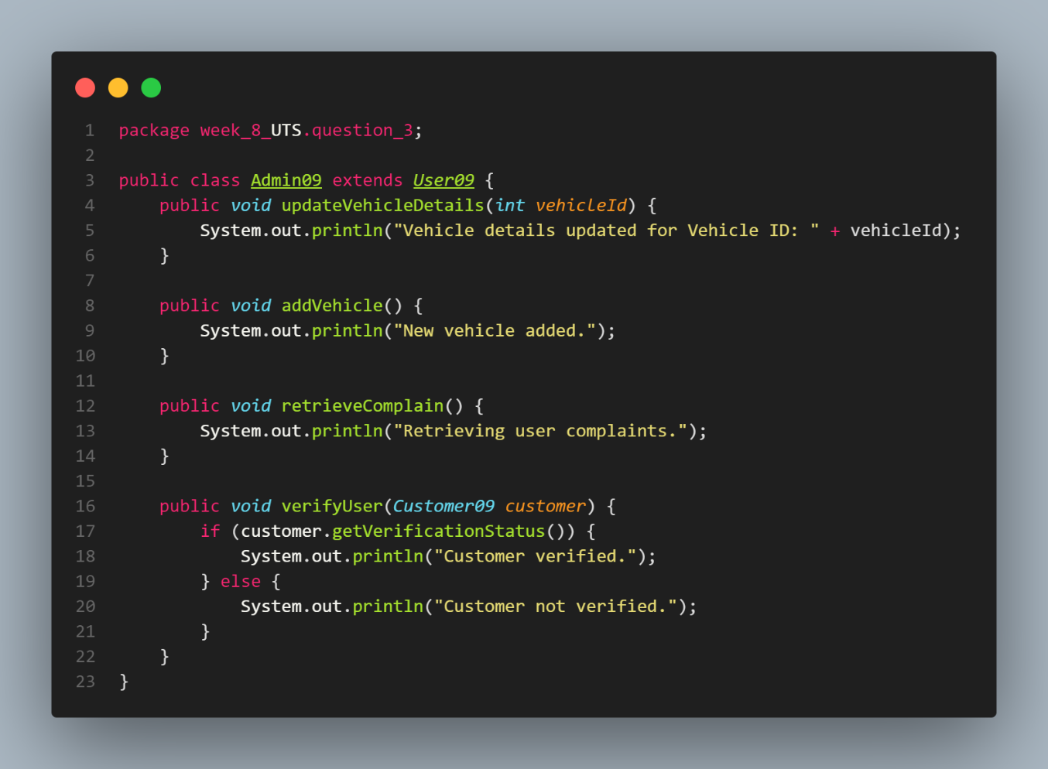

* Main

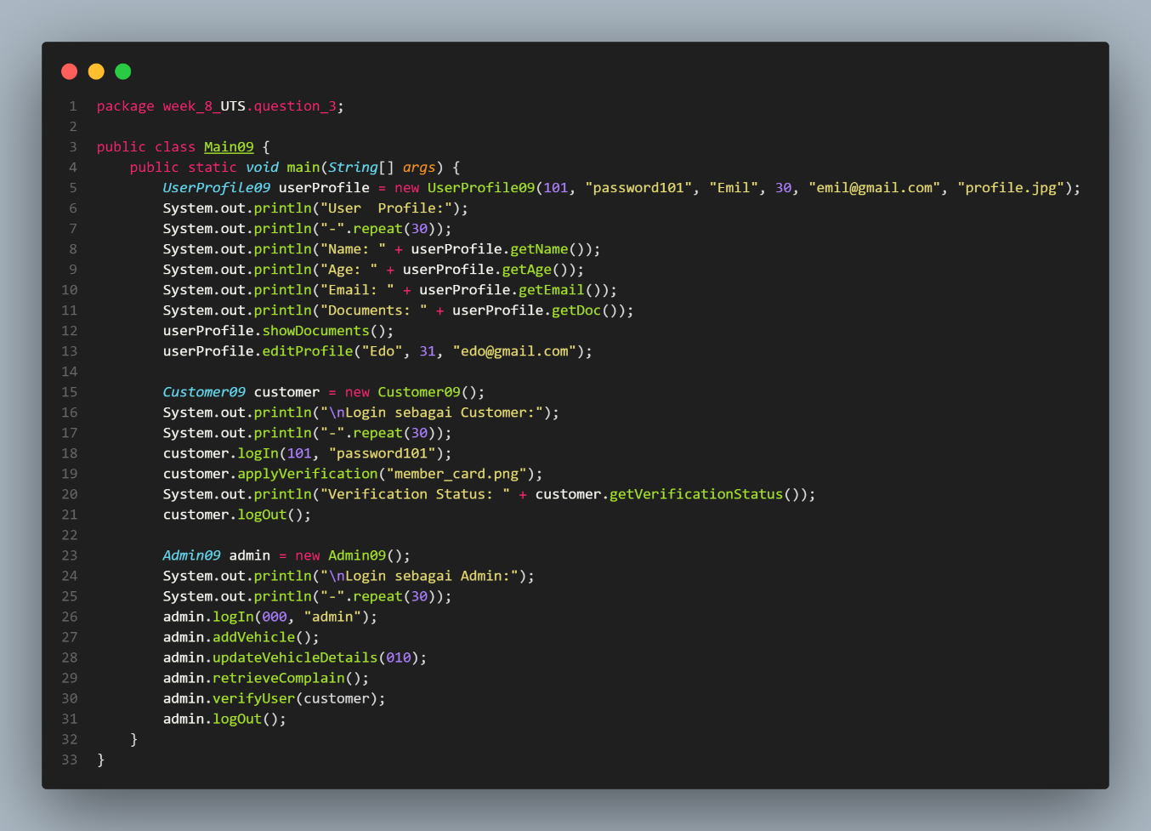

**---- Good Luck ----**